19.21: a) Using Equation (19.12), 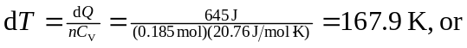T = 948 K.
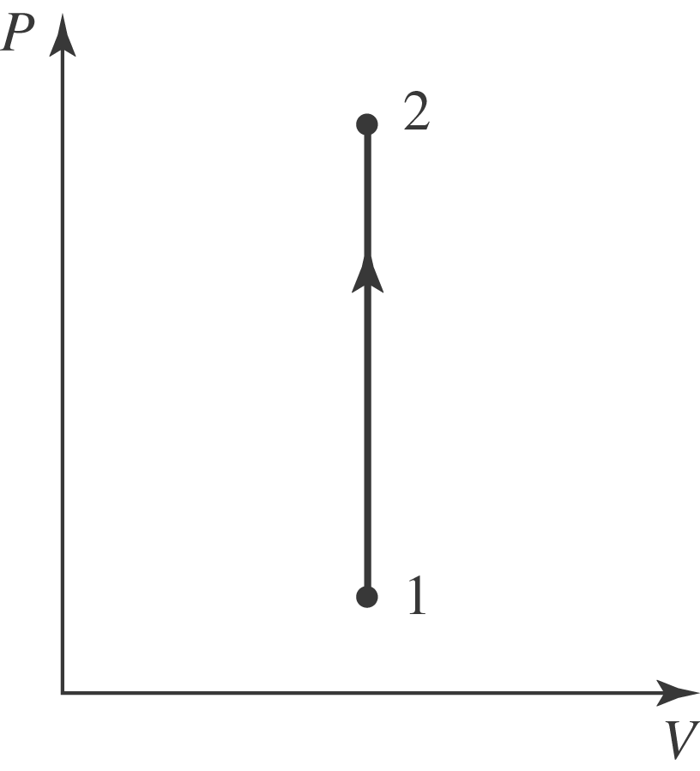
b) Using Equation (19.14),
